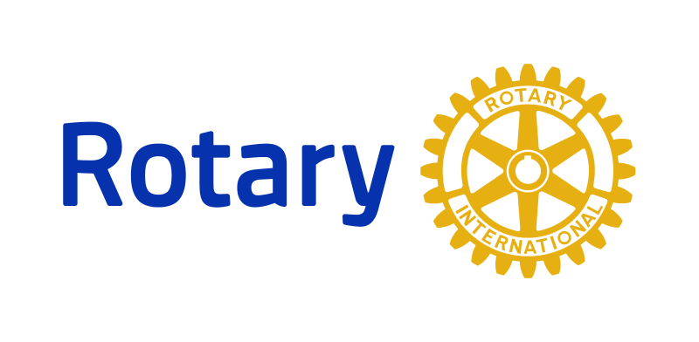**New Member**

**Handbook**

**(Expanded Version)**

**A True Rotarian is…**

*“not a builder of monuments of brick and stone. If we work upon marble it will perish; if we work on brass, time will deface it; if we erect temples, they will crumble into ruins.  But if we work upon immortal minds, if we imbue them with the full meaning of the Spirit of Rotary as expressed in our Objects and with the fear of God and love of our fellow men, we are engraving on those tablets something that will brighten all eternity and make Rotary an immortal force as long as civilization shall endure”*

 Arch Klumph, Cleveland Rotarian, father of the Rotary Foundation and Rotary International President, 1916-17

**“Service above Self”**

**“He Profits Most Who Serves Best”**

**The Essentials for New Members**

The objective of the New Member Orientation is to communicate to you, the newest members of our club, basic information about Rotary, regarding the benefits, responsibilities, and opportunities for service related to Rotary membership.

**The benefits of Rotary membership include:**

* Participating in activities that have a positive impact on our local community as well as communities in other countries
* Meeting individuals in different professional capacities
* Associating with a group with high standards of character and integrity.

However, being a Rotarian requires a commitment of time and resources. **The responsibilities of Rotary membership include:**

* Paying dues to the club and Rotary International
* Participating in club projects, programs, and activities
* Proposing qualified individuals for membership
* Accepting Club leadership assignments
* Contributing annually to the Rotary Foundation

With responsibility comes opportunity. Based in thousands of communities around the world, Rotary is often in an ideal position to affect positive change – improving the lives of countless people and giving its members many opportunities for service. **Potential opportunities for Rotary service:**

* Club members can develop and conduct their own service projects with Board approval.
* Rotary offers the chance to serve both locally and globally.
* The Rotary Foundation offers the chance to participate in a wide variety of educational and humanitarian programs.
* Club members can make a difference by contributing funds to the Rotary Foundation.

In summary, you may think of this New Member Orientation as Rotary 101. And as with any introductory course, you are sure to have many questions. You are urged to ask them.

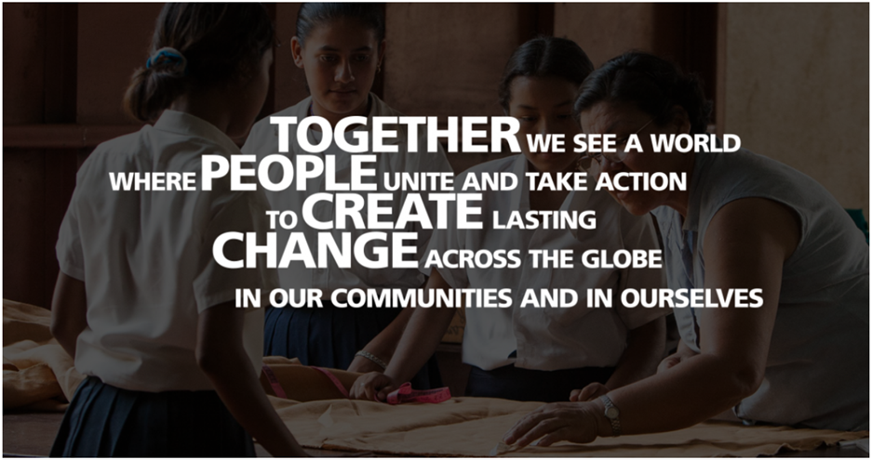

**Service Above Self**

Rotarians are business and professional leaders who take an active role in their communities while greatly enriching their personal and professional lives. A Rotary club contains a diverse group of professional leaders from the community that the club serves.

* Membership in a Rotary club offers a number of benefits, including:
* Effecting change within the community.
* Developing leadership skills.
* Gaining an understanding of — and having an impact on — international humanitarian issues.
* Developing relationships with community and business leaders.

Through Rotary's service programs, a Rotary club can have a significant effect on the quality of life in its community. Programs of The Rotary Foundation offer opportunities to form international partnerships that help people in need worldwide. More than 1.2 million Rotarians make significant contributions to the quality of life at home and around the globe. This ideal is embodied in Rotary’s motto, Service Above Self.

**Core Values**

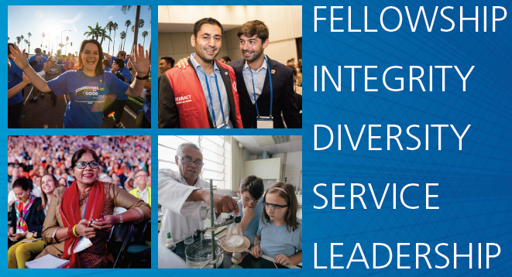

**History of Rotary**

The world's first service club, the Rotary Club of Chicago, Illinois, USA, was formed on February 23, 1905, by Paul P. Harris, an attorney who wished to recapture in a professional club the same friendly spirit he had felt in the small towns of his youth. The name "Rotary" derived from the early practice of rotating meetings among members' offices.

Rotary’s International Growth

Rotary's popularity spread throughout the United States in the decade that followed; clubs were chartered from San Francisco to New York. By 1921, Rotary clubs had been formed on six continents, and the organization adopted the name Rotary International a year later.

Emphasis on Community Service

As Rotary grew, its mission expanded beyond serving the professional and social interests of club members. Rotarians began pooling their resources and contributing their talents to help serve communities in need. The organization's dedication to this ideal is best expressed in its principal motto: Service Above Self. Rotary also later embraced a code of ethics, called the 4-Way Test, which has been translated into hundreds of languages.

Working for Peace

During and after World War II, Rotarians became increasingly involved in promoting international understanding. In 1945, 49 Rotary members served in 29 delegations to the United Nations Charter Conference. Rotary still actively participates in UN conferences by sending observers to major meetings and promoting the United Nations in Rotary publications. Rotary International's relationship with the United Nations Educational, Scientific, and Cultural Organization (UNESCO) dates back to a 1943 London Rotary conference that promoted international cultural and educational exchanges. Attended by ministers of education and observers from around the world, and chaired by a past president of RI, the conference was an impetus to the establishment of UNESCO in 1946.

The Rotary Foundation

An endowment fund, set up by Rotarians in 1917 "for doing good in the world," became a not for-profit corporation known as The Rotary Foundation in 1928. Upon the death of Paul Harris in 1947, an outpouring of Rotarian donations made in his honor, totaling US$2 million launched the Foundation's first program — graduate fellowships, now called Ambassadorial Scholarships. Today, contributions to The Rotary Foundation total more than US$80 million annually and support a wide range of humanitarian grants and educational programs that enable Rotarians to bring hope and promote international understanding throughout the world.

Polio Eradication

In 1985, Rotary made a historic commitment to immunize all of the world's children against polio. Working in partnership with nongovernmental organizations and national governments thorough its PolioPlus program, Rotary is the largest private-sector contributor to the global polio eradication campaign. Rotarians have mobilized hundreds of thousands of PolioPlus volunteers and have immunized more than one billion children worldwide. Rotary has contributed more than US$650 million to the polio eradication activities in 122 countries.

Rotary Today

As it approached the dawn of the 21st century, Rotary worked to meet the changing needs of society, expanding its service effort to address such pressing issues as environmental degradation, illiteracy, world hunger, and children at risk. The organization admitted women for the first time (worldwide) in 1989 and claims more than 145,000 women in its ranks today. Following the collapse of the Berlin Wall and the dissolution of the Soviet Union, Rotary clubs were formed or re-established throughout Central and Eastern Europe. Today, 1.2 million Rotarians belong to some 33,000 Rotary clubs in more than 200 countries and geographical areas.

Rotary Milestones

1905: First Rotary club organized in Chicago, Illinois, USA

1908: Second club formed in San Francisco, California, USA

1910: First Rotary convention held in Chicago, Illinois, USA

1912: The Rotary Club of Winnipeg, Manitoba, Canada, becomes the first club outside the United States to be officially chartered. (The club was formed in 1910.)

1917: Endowment fund, forerunner of The Rotary Foundation, established 1932 4-Way Test formulated by Chicago Rotarian Herbert J. Taylor

1945: Forty-nine Rotarians help draft United Nations Charter in San Francisco

1947: Rotary founder Paul Harris dies; first 18 Rotary Foundation scholarships granted

1962: First Interact club formed in Melbourne, Florida, USA

1965: Rotary Foundation launches Matching Grants and Group Study Exchange programs

1985: Rotary announces PolioPlus program to immunize all the children of the world against polio

1989: Council on Legislation opens Rotary membership to women worldwide; Rotary clubs chartered in Budapest, Hungary, and Warsaw, Poland, for first time in almost 50 years

1990: Rotary Club of Moscow chartered first club in Soviet Union

1990-91: Preserve Planet Earth program inspires some 2,000 Rotary-sponsored environmental projects 1994 Western Hemisphere declared polio-free

1999: Rotary Centers for International Studies in Peace and Conflict Resolution established

2000: Western Pacific declared polio-free

2001: 30,000th Rotary club chartered

2002: Europe declared polio-free; first class of 70 Rotary Peace Scholars begin study

2003: Rotarians raise more than US$118 million to support the final stages of polio eradication

2004: RI’s largest convention with 45,381 attendees, held in Osaka, Japan

2005: Rotary Celebrates centennial in Chicago, Illinois, USA

2006-07: Rotary recognizes the millionth Paul Harris Fellow

2007-08: Rotary receives US $100M grant from the Gates Foundation to help eradicate polio

2009: India declared polio-free

2020: Africa declared polio-free

**The Object of Rotary**

The Object of Rotary is to *"encourage and foster the ideal of service as a basis of worthy enterprise."* There are four areas by which this “ideal of service” is fostered:

First: The development of acquaintances as an opportunity of service.

Second: High ethical standards in business and professions, the recognition of the worthiness of all useful occupations, and the dignifying by each Rotarian of his occupation as an opportunity to serve society.

Third: The application of the ideal of service by every Rotarian to this personal, business and community life.

Fourth: The advancement of international service, goodwill and peace through a world fellowship of business and professional persons united in the ideal of service.

**The Avenues of Service**

The *Four Avenues of Service* represent the four elements of the Object of Rotary. They are:

1. *Club Service*: Providing service to the Rotary club to enable it to run efficiently in the spirit of fellowship.
2. *Vocational Service:*Putting high standards of conduct into practice in the business and professional lives of Rotarians.
3. *Community Service:* Identifying needs in the Rotary Club’s community and addressing these needs with service projects.
4. *International Service:*Working for international understanding and peace by promoting goodwill among all people.

**The Four Way Test**

 One of the most widely printed and quoted statements of business ethics in the world is the Rotary “4 Way Test”. It was created by Rotarian Herbert J. Taylor in 1932 when he was asked to take charge of the Chicago- based Club Aluminum Company, which was facing bankruptcy. Taylor drew up a 24 word code of ethics for all employees to follow in their business and professional lives. The 4-Way Test became a guide for all employees and all relations with the dealers and customers. It was credited with the survival and future success of the company. The 4-Way Test was adopted by Rotary International in 1943. Herb Taylor became president of Rotary International during 1954-55

 Most Rotary clubs open or close their meetings with the recitation of the 4-Way Test.

**Of the things we think, say or do:**

1. Is it the TRUTH?
2. Is it FAIR to all concerned?
3. Will it build GOODWILL and BETTER FRIENDSHIPS?
4. Will it be BENEFICIAL to all concerned?

**Declarations of Rotarians in Business and Professional Relations**

As a Rotarian engaged in a business or profession, I am expected to:

1. Consider my vocation to be another opportunity to serve.
2. Be faithful to the letter and the spirit of the ethical codes of my vocation, to the laws of my country, and to the moral standards of my community.
3. Do all in my power to dignify my vocation and to promote the highest ethical standards of my chosen vocation.
4. Be fair to my employer, employees, associates, competitors, customers, the public and all those with whom I have a business or professional relationship.
5. Recognize the honor and respect due to all occupations which are useful to society.
6. Offer my vocational talents: to provide opportunities for young people, to work for the special needs of others, and to improve the quality of life for my community.
7. Adhere to honesty in my advertising and in all representations to the public concerning my business or profession.
8. Neither seek from nor grant to a fellow Rotarian a privilege of advantage not normally accorded others in a business or professional relationship.

**The Rotary Motto**

The principal motto of Rotary is: **“Service  Above Self”**

The secondary motto is:  **“He Profits Most Who Serves Best”**

**The Rotary Wheel Emblem**



In 1923, Rotary adopted as its official symbol the present gear wheel with 24 cogs and six spokes. An engineer recognized it would not work if it did not have a “keyway” so later in 1923, the keyway was added to the official Rotary emblem.

The emblem is made into a lapel pin presented to new members of Rotary, and Rotarians are encouraged to wear the pin in their daily business activities.

**The Organization of Rotary International**

Rotary is essentially a grassroots organization, with most of its service efforts being carried out at the club level. The district and international structure is designed to support the clubs and help them provide more service in their communities and abroad.

Clubs – Rotarians are members of their clubs, and the clubs are members of the global association known as Rotary International. Each club elects is own officers and enjoys considerable autonomy within the framework of the standard constitution and the constitution and bylaws of Rotary International.

Districts and Zones – Clubs are grouped into 530 Rotary districts, each led by a district governor who is an officer of Rotary International and represents the RI board of directors in the field. The District administration, including assistant district governors and various committees, guides and supports the clubs. Though selected by the clubs of the district, a governor is elected by all of the clubs’ worldwide meeting at the RI convention. Zones are geographical grouping of districts.

RI Board – Traditionally, the RI president, who is elected annually, develops a theme and emphasis for the year. The 19-member RI board of directors, which includes the RI president and president-elect, administers Rotary International. These officers are also elected at the convention; the selection process for choosing directors and the nominating committee for president are based on zones, each of which comprises approximately 15 districts. The board meets quarterly to establish policies.

The Secretariat – Rotary International is headquartered in the Chicago suburb of Evanston, Illinois, USA, with seven international offices in Argentina, Australia, Brazil, India, Japan, Korea, and Switzerland. The RI in Great Britain and Ireland (RIBI) office, located in England, serves clubs and districts in that region. The Secretariat’s active managing officer is the RI general secretary, who heads a 650-member staff working to serve Rotarians worldwide.

**Clubs**

All clubs are subject to the rules and regulations as laid down by Rotary International and District Rules. Clubs are required to adopt and abide by the Rotary International Standard Club Constitution. Each club has some voice in establishing its own By-Laws, but they must conform to the Rotary International Standard Club By-Laws.

**Club Models**

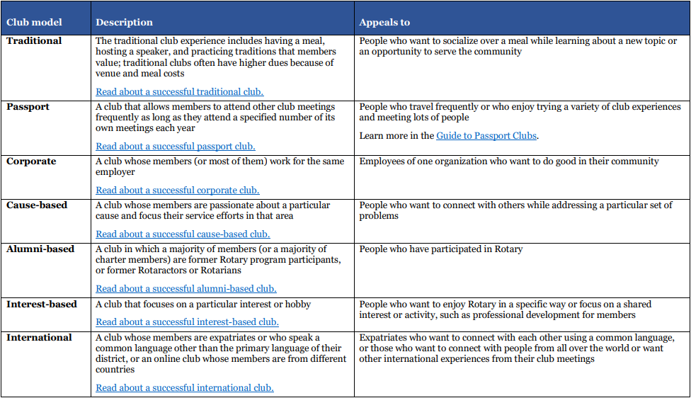

Satellite Clubs

* A satellite club is a branch of the sponsor club that meets at a different time or location than the sponsor club. The satellite club may also have lower member costs (meal costs, etc.). The purpose is to provide an opportunity for those who want to be Rotarians but cannot meet when/where the sponsor club does.
* The satellite club members are Rotarians and considered members of the sponsor club.
* Only eight members and the support of a sponsor club are needed to start a satellite club.
* Satellite clubs often offer a different club environment or meeting time and location from their sponsor club.
* Like a Rotary club, satellite clubs hold regular meetings, have bylaws and a board, and get involved in community service projects. The sponsor club provides advice and support.
* In some cases, satellite clubs may grow and apply to become a separate Rotary club.
* Satellite club members are Rotarians.

**Interact**

Interact is a Rotary club for high school students designed to provide opportunities for boys and girls of high school age to work together in a world fellowship of service and international understanding. Each Interact club must be sponsored and supervised by a Rotary Club and requires a faculty sponsor at the school where the club is organized. The Interact club must plan annual projects of service to its school, community or world.

**Rotaract**

Rotaract is a Rotary club at the college and/or young professional level. Rotaracters can be dual members of Rotary.

**Our Rotary District and Zone**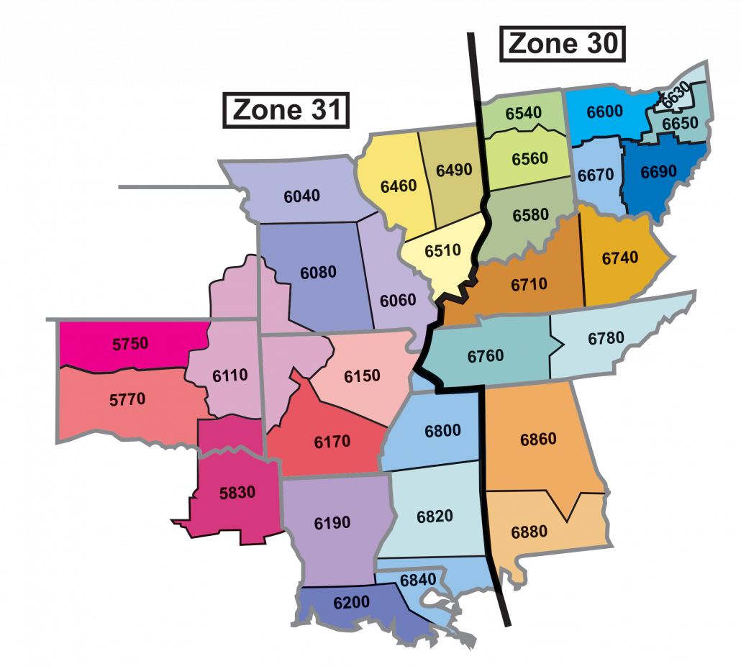

This Rotary Club is a member of District 6690. District 6690 consists of 58 clubs with a membership of 3200 Members. District 6690 is in Zone 30. Zones 30 and 31 have been combined to be Zones 30/31.

The District Governor is the Single officer of Rotary International in this District. Each District Governor has been extensively trained to do his or her job while serving a year as District Governor. In addition, each governor and if possible their spouse must attend a Governors Elect training meeting held in the spring of the year in which they are to become governor. The governor serves for one year starting on July 1.

**Some of the duties of the District Governor are:**

| - | Strengthen Existing Clubs |
| --- | --- |
| - | Promote and implement the programs of Rotary International |
| - | Make an official visit to each club in the district |
| - | Publish a monthly District Newsletter, Produce a District Directory outlining the goals for Rotary International and the District for the coming year, listing the District officers and committee chair persons listing the Clubs, Club Officers and meeting times and locations as well as a schedule of major District Events. |

**Assistant Governors**: Since it is impossible for an individual to be everywhere at once, the District Governor of District 6630 has Assistant Governors to assist him or her. The Assistant Governor for the Rotary Club of Mentor is Lee Quignano from the Rotary Club of Mentor.

**District Conference**

The District Conference is the annual meeting for the District and is held in the spring of the year. The purpose of the District Conference is for fellowship, review of the programs for the District for the year, to hear speakers including the President of RI or representatives appointed by the President to attend the conference and to conduct any business or vote on resolutions presented.

**District Recognition**

RI Presidential Citation: This is an award for clubs that have achieved the goals set by the President of RI in each of the four avenues of service

District 6690 Awards: The leadership of District 6690 present a range of awards to Rotary Clubs easy year.

**Rotary International**

The headquarters of Rotary International (RI) is located at One Rotary Center, 1560 Sherman Avenue, Evanston, Illinois, 60201.

The RI internet website is[www.rotary.org](http://www.rotary.org/)

RI holds an international Conference in June of each year for all persons who desire to attend. The conference is normally held every other year in the U.S. alternating with a major international city. The number of delegates often approaches 30,000 representing Rotarians from all over the world.

**The Unique Service Club**

There are three areas in which Rotary Clubs differ from all of the other service clubs in the world.

| I | Member qualifications |
| --- | --- |
| II | Classification system for selection of members based on their business or profession |
| III | Attendance Requirements |

I.                   Types of Membership:

1.        Active: A person of good character and reputation who is a sole proprietor or in a leadership, supervisory or executive position in a business or profession or a person with discretionary power over their time. A club may have up to five members with the same classification or if the club has more than 50 members, up to 10% of the clubs membership.

2.        Honorary. A person who has performed meritorious service in furthering Rotary ideals may be elected by the club as an Honorary member. This designation is normally reserved for someone who for one reason or another would not normally be considered for active membership. The honorary member has the rights and privileges of active members in their own club only; except that they may not hold office in the club and are not subject to attendance requirements. The designation is valid until withdrawn by the club’s board of directors.

Membership in Rotary is not Universal

It must be remembered that membership in Rotary is not universal. One is a member of only the local club. If you move to an area outside of your club’s jurisdiction, you must join another club to remain a member of Rotary. Under the new rules effective July 1, 2001 your present club or you as an individual may request that your membership be transferred to another club without the normal requirement of being proposed by a member.

II. Classification System:

The Rotary plan of membership provides a means for having in the Club, a representative of every recognized business, profession or institution activity in the community so far as is possible. This ensures a wide cross of community representation and insures the club represents the whole of the business and professional community in the area designated for the club to draw its membership.

A classification describes the principal and recognized activity of a company, institution, business or profession. It should be clearly understood that classifications are determined by the activities or services to society, rather than the position held by an individual. In other words, if a person is president of a bank, they will hold the classification of “Banker” and not be classified as “Bank President”.

The basic idea of the Rotary membership classification system is to provide a Club with membership representing all of the business and professional activities of the community.

The classification system is seeing less and less use these days.

Proposing a New Member

It is important for club members to understand that a prospective member is not formally proposed until the Board of Directors has approved an application. The club member proposing a new member will fill out an application and deliver it to the Club Secretary. It should be checked by the membership committee and the classification committee to insure the individual is qualified as outlined in the club by-laws. Once approved, the application with board approval is then taken to the prospective member along with a letter that outlines the privileges and obligations associated with being accepted for membership in Rotarian. The proposed member is then asked to sign the application signifying that they understand the privileges and obligations and that they agree to have their name placed before the club for approval.

The change to the by-laws made by the Council on legislation also provides that if a Rotarian that is transferred or for other reason leaves the area serviced by the local club, the losing club or the member may request that they be admitted to membership in another club that services the area to which the individual is moving. Unless the classification for the individual is filled, or another valid reason for objection is received, the individual **will be admitted to the new club.**

**Financial Responsibilities of a Rotarian**

Rotarians are expected to take care of their financial obligations to the Club promptly. The mandatory obligations are:

1.        Club dues are billed quarterly. When a member joins the club they will be billed for a pro-rated amount of the semi-annual payment.

2.        Dues are due within 30 days. If a member is more than 30 days in arrears the secretary will notify the club president who will take appropriate action which may include proposing to the board of directors that the member be dropped from membership.

3.        Club dues include RI dues, a subscription (mandatory) to the Rotarian magazine and District operations dues. The remainder is used to pay Club operating expenses.

**Fellowship and Attendance**

One of the many benefits of Rotary Club membership is the luxury of being able to travel the world and never miss the fellowship of a weekly meeting. Club members are welcome and encouraged to visit clubs while traveling to make-up the meeting missed back home.

Rotary International provides an online service to locate clubs and meeting times and places worldwide at www.rotary.org. Click on the “club locator” link at the top of the home page. Rotary District 6690 also maintains a list of club meeting times and places on its web page at <https://rotarydistrict6690.org/clubdirectory>

But Rotarians often ask what options exist if there is not a club in the area of travel, or if the member is home but an emergency causes him or her to miss a meeting. One option is to attend a regular meeting of a local Rotaract or Interact club, Rotary Community Corps, or Rotary Fellowship. According to the Standard Rotary Club Constitution, attending one of these meetings counts as a make-up. Another option is to spend time participating in an interactive activity on a Rotary e-club Web site. A visit to one of these e-clubs satisfies a club member's make-up requirement. Additionally, members may make-up by attending a meeting of the board of directors of their club, or by attending a District meeting, such as District Conference, District Assembly/Club Leadership Training Seminar, Presidents Elect Training Seminar, Foundation Seminar, Membership Seminar, or District Installation. Attendance at a Rotary International meeting, such as the International Conference, also counts for make-up credit.

**The Rotary Foundation**

The Rotary Foundation is the cornerstone for Rotary service and programs. It is trust fund that is administered by 13 trustees who are appointed by the RI Board of Directors. It was initiated by Rotary’s sixth President and Cleveland Rotarian Arch Klumpf at the 1917 International Convention in Atlanta, Georgia, USA, the creation of an "endowment fund for Rotary . . . for the purpose of doing good in the world in charitable, educational, and other avenues of community service." A few months later, the endowment received its first contribution of $26.50 from the Rotary Club of Kansas City, Missouri, USA.

In 1928, when the endowment fund had grown to more than US$5,000, the fund was renamed The Rotary Foundation, and it became a distinct entity within Rotary International. Five Trustees, including Klumph, were appointed to "hold, invest, manage, and administer all of its property as a single trust, for the furtherance of the purposes of RI." Two years later, the Foundation made its first grant of US$500 to the International Society for Crippled Children. The ISCC — created by Rotarian Edgar F. "Daddy" Allen — later grew into the Easter Seals organization. After a slow start due to two world wars and the depression, contributions really took off in 1947 with the death of Paul Harris. Memorial gifts poured in to honor the founder of Rotary.

After Rotary founder Paul P. Harris died in 1947, contributions began pouring into Rotary International, and the Paul Harris Memorial Fund was created for the purpose of building the Foundation. That same year, the first Foundation program — the forerunner of the Rotary Ambassadorial Scholarships program — was established. Then in 1965-66, three new programs were launched Group Study Exchange, Awards for Technical Training, and Grants for Activities in Keeping with the Objective of The Rotary Foundation, which was later called Matching Grants.

The Health, Hunger and Humanity (3-H) program was launched in 1978, with the Rotary Volunteers program being created as a part of 3-H in 1980. The PolioPlus program was announced in 1984-85, and the following year saw the introduction of Rotary Grants for University Teachers. The first Peace Forums were held in 1987-88, leading to the establishment of Rotary Peace Programs. Then in 1989, 1963-64 RI President Carl P. Miller and his wife, Ruth, donated US$1 million to establish the Discovery Grants program.

Throughout this time, support of the Foundation grew tremendously. Since that first $26.50 donation in 1917, the Foundation has received contributions totaling more than US$2.395 billion. More than US$223.8 million was contributed in 2008-2009 alone. As of 2009,, some 1,188,782 individuals have been recognized as Paul Harris Fellows — that is, someone who has contributed US$1000 or has had that amount contributed in his or her name. Such strong support and involvement of Rotarians worldwide ensures a secure future for The Rotary Foundation as it continues its vital work for international understanding and world peace.

The crowning achievement of the Foundation to date has been the **Polio Plus** program. Rotary under the leadership of RI President Carlos Canseco made a commitment to immunize the world’s children against polio in 1985 and became a spearheading partner in the Global Polio Eradication Initiative three years later. The other partners are the World Health Organization, the U.S. Centers for Disease Control and Prevention, and UNICEF.

Rotary’s primary responsibilities include fundraising, advocacy, and volunteer recruitment. To date, Rotary has contributed nearly $700 million to the eradication effort, an amount that will grow to more than $850 million by the time the world is certified polio-free.

With nearly 33,000 clubs in over 200 countries and geographical areas, Rotary reaches out to national governments worldwide to generate crucial financial and technical support for polio eradication. Since 1995, the advocacy efforts of Rotary and its partners have helped raise more than $3 billion in vital funding from donor governments. Rotary clubs also provide “sweat equity” on the ground in polio-affected communities, which helps ensure that leaders at all levels remain focused on the eradication goal. Over the years, Rotary club members have volunteered their time and personal resources to reach more than two billion children in 122 countries with the oral polio vaccine.

Thanks to Rotary and its partners, the number of polio cases has been slashed by more than 99 percent, preventing five million instances of childhood paralysis and 250,000 deaths. When Rotary began its eradication work, polio infected more than 350,000 children annually. In 2007, fewer than 2,000 cases were reported worldwide.

But the polio cases represented by that final 1 percent will be the most difficult and expensive to prevent for a variety of reasons, including geographical isolation, worker fatigue, armed conflict, and cultural barriers. That’s why it’s so important to generate the funding needed to finish the job. To ease up now would be to invite a polio resurgence that would condemn millions of children to lifelong paralysis in the years ahead.

The bottom line is this: As long as polio threatens even one child anywhere in the world, all children – wherever they live – remain at risk.

The US$200 million funding agreement between Rotary and the Bill & Melinda Gates Foundation marks another milestone in Rotary’s 20-year legacy of polio eradication work.

http://www.rotary.org/SiteCollectionImages/images/endpolio/text_quote.gif

**The Two Methods of Funding the Rotary Foundation**

The Annual Fund: The Rotary Foundation is financed by primarily by voluntary contributions from Rotarians, Rotary Clubs, and other individuals, corporations or charitable trust funds. Each years annual donations are placed in a trust for investment for and then spent the third year. The income pays all operating costs of the Foundation so 100% of an contribution is utilized for programs. The Foundation is a 501 C-3 organization for purposes of Income tax to U.S. Investors or foreign investors where applicable by the laws of their country.

The Endowment Fund: In addition, a permanent fund which is an endowment fund has been established and earnings from this fund are used to finance programs.

**The Annual Fund**

The annual fund is financed by contributions made to ***Paul Harris Fellowships.*** When a Rotarian or a Club makes a $1,000 donation to the foundation in the name of an individual, the individual is designated as a Paul Harris Fellow.  The fellowship may be in the Rotarians name or may be designated to honor some other individual (living or dead) such as:

| - | Another Rotarian |
| --- | --- |
| - | Family members including spouses and children |
| - | As a memorial to a relative or friend |
| - | Community leaders |

Contributions may be by lump sum, or more commonly by accumulation of contributions over a period of up to ten years.

**There are three levels of Paul Harris fellowship recognition:**

| Paul Harris Sustaining Membership: | $100 to $999 Contribution |
| --- | --- |
| Paul Harris Fellow: | $1,000 to $1,999 Contribution |
| Multiple Paul Harris Fellow: | $2,000 plus in Multiples of $1,000 |

**Four primary ways to become a Paul Harris Fellow:**

1. Become a Sustaining Member by contributing $100 to the foundation and continuing to give in increments of at least $100 until you have contributed $1,000 within a 10 year maximum period.
2. You contribute $1,000 as a lump sum or as an amount necessary to bring your accumulated contributions to $1,000.
3. Your club or an individual contributes $1,000 in your name to honor you.
4. You utilize a matching funds grant from your club or District to complete your fellowship.

**Multiple Paul Harris Fellow**

Multiple Paul Harris Fellow recognition is extended at subsequent $1,000 levels (e.g., $2,000, $3,000). Recognition consists of a pin with additional stones corresponding to the recipient’s recognition amount level.

$2,000-2,999.99—one sapphire

$3,000-3,999.99—two sapphires

$4,000-$4,999.99—three sapphires

$5,000-$5,999.99—four sapphires

$6,000-$6,999.99—five sapphires

$7,000-$7,999.99—one ruby $8,000-$8,999.99—two rubies

$9,000-9,999.99—three rubies

**Paul Harris Society**

The Paul Harris Society is a district-administered recognition for those who elect to personally contribute US$1,000 or more each year to the Annual Programs Fund. District 7610 administers the program for the Rotary Club of McLean, which has more Paul Harris Society members than any other club in the District. Paul Harris Society contributions are eligible for Rotary Foundation Sustaining Member, Paul Harris Fellow, Multiple Paul Harris Fellow, and Major Donor Recognition.

**Major Donor**

The Rotary Foundation recognizes those individuals or couples whose combined personal giving has reached US$10,000, regardless of the gift designation. Major Donors may elect to receive a crystal recognition piece and pin(s) commemorating the gift at each new recognition level.

$10,000-24,999.99—Level One

$25,000-49,999.99—Level Two

$50,000-99,999.99—Level Three

$100,000-499,999.99—Level Four

$500,000-999,999.99—Level Five

$1,000,000 or greater—Level Six

**Arch C. Klumph Society**

Donors who contribute US$250,000 or more may have their portraits displayed in the Arch C. Klumph Gallery at Rotary International’s World Headquarters in Evanston, Illinois. Donors receive a certificate signed by the President of Rotary International and the Chairman of The Rotary Foundation, and they are invited to a special event at annual RI Conventions. The society is named in honor of The Rotary Foundation’s founder, Arch C. Klumph.

**The Endowment Fund**

The endowment fund was started to provide a steady income to the foundation. The interest from this fund is used annually through grants and programs. Individuals donating over $25,000 to the Permanent Fund can create a named fund whose proceeds are directed to the programs they designate.

**Benefactor**

A Benefactor is someone who informs The Rotary Foundation in writing that he or she has made a provision in his/her estate plans for The Rotary Foundation or by making an outright gift of US$1,000 or more to the Permanent Fund. Benefactor recognition consists of a certificate and insignia to be worn with a Rotary pin.

**Bequest Society**

The Rotary Foundation recognizes those couples or individuals who have made commitments in their estate plans totaling $10,000 or more. Donors may elect to receive an engraved crystal recognition piece and a Diamond Circle pin commemorating the commitment at each new recognition level.

$10,000 to 24,999.99 – Level One

$25,000 to 49,999.99 – Level Two

$50,000 to 99,999.99 – Level Three

$100,000 to 499,999.99 – Level Four

$500,000 to 999,999.99 – Level Five

$1,000,000 or greater – Level Six

**Unique Features of the Rotary Foundation Funding**

The foundation is unique to charitable foundations for a number of reasons including:

1. 100% of the contributions are spent on programs of the Foundation and not on administrative expenses. The money received in a Rotary year is invested and programmed for expenditure at the end of the second year. Thus, the interest pays all administrative expenses.
2. Neither Rotarians nor their direct linear family members are eligible to receive a financial benefit from the Foundation as it is a non-profit charitable organization. Thus, the only benefit to Rotarians and their families is the knowledge and satisfaction that their contributions are used to serve others.

**Rotary Foundation Awards**

Two special awards are presented by Trustees of the Rotary Foundation to Rotarians in our District who render unusual service to the Foundation:

**Citation for Meritorious Service:** Each year, the District Governor may recommend a limited number of individuals for the Citation for Meritorious Service to the Foundation. This award recognizes significant and dedicated service by a Rotarian in the District to promote the programs of the Rotary Foundation and thus advance the Foundation’s goal of better understanding and friendly relations among people of the world.

**Distinguished Service Award**: One member of the District may be recognized with the Distinguished Service Award each year. It is based on a much broader basis and spreads beyond the District level with normally covers and extended period of time. Individuals nominated for their award must have already received the Citation for Meritorious Service

**Other Rotary Programs**

In addition to the Foundation programs, there are several other programs that are of special interest to the District:

**Youth Exchange**

The youth exchange program is one of Rotary’s most popular programs to promote international understand and develop lifelong friendships. It offers young people interesting opportunities and rich experiences to see another part of the world. High school students usually spend a full academic year in the home of one or more Rotarians. Shorter programs are also available. Unlike the Foundation programs, the exchange is arranged directly with the exchange between a student in a foreign country and a student in the District. Funding is the responsibility of the individual students and their families. Some Rotary clubs assist in the funding, but the majority of the expense is borne by the student’s family. Rotary serves as a clearing house by helping to publicize the program and accept names of student’s seeking to use the exchange program. Rotary sets the rules that must be observed including restrictions on driving in a foreign country by students while participating in an exchange program. The program is open to dependants of Rotarians since the family or club funds sponsor the exchange.

**RYLA**

The Rotary Youth Leadership Award (RYLA) program is a District run program for high school students selected and sponsored by clubs within the District. The youth spend the weekend in a challenging program conducted by special guest speakers and leaders to provide inspiration, leadership training and social activities. The program is designed to teach teamwork and develop leadership skills and good citizenship.

**What is Expected of You as A Rotarian**

1. Attend meetings of your Rotary Club on a regular basis.

2.  Make up meetings that you miss.

3.  Stay current with your Club financial obligations.

4. Attend each meeting of the club committee to which you have been assigned. If not assigned to a committee, select one and volunteer.

5.  Try to attend a District Conference, a Mid Year Review and District Foundation seminar during your first year as a Rotarian.

6.  Become a Paul Harris Fellow or a Sustaining Member within one year of your induction.

7.  Bring in a new member to the Club in your first year.

8.  Wear your Rotary Pin on a Daily Basis.

9.  Practice the Four Way Test in personal and professional life.

10. Put service above self.

**Interesting Rotary Facts**

1. Many clubs are “singing” clubs – after the invocation, they will sing a patriotic or seasonal song as a group as well as the national anthem. The Pledge of Allegiance follows this. Harry Ruggles – the fifth Rotarian – started this tradition.
2. The RI world headquarters is in Evanston, IN.
3. Exchanges of banners between clubs by visitors is a pleasant reminder of the worldwide reach of Rotary.
4. Rotarians shall expect nor receive preferential service because they are dealing with a Rotarian nor is Rotary membership to be used to advance one’s business purpose. Normal development of business relationships may occur through acquaintances made through Rotary and this is normal and expected; one simply is not to use Rotary membership to business advantage.
5. Rotary’s first appeal for aid to disaster victims was in 1913 when $25,000 was given for flood relief in Ohio and Indiana.
6. Rotary’s first community service project was to provide a “comfort station” outside of Chicago’s City Hall in 1906.
7. The Rotary Foundation’s Ambassadorial Scholarship program is the world’s largest privately-funded scholarship program.
8. Each RI president selects a specific jacket color that is worn by her/him, his representatives, and district governors at all official Rotary functions. Due to the diverse thoughts on fashion worldwide, the colors and styles chosen may not be fashionable in every culture worldwide. The color and style of these jackets is a subject of much speculation prior to their unveiling at the International Assembly.
9. Each RI president selects a theme for their year.
10. Each month has a specific meaning/theme in Rotary. For example, November is Foundation month.